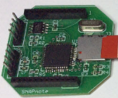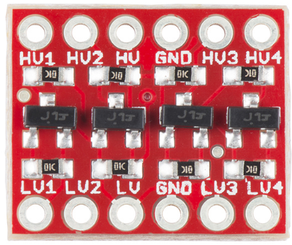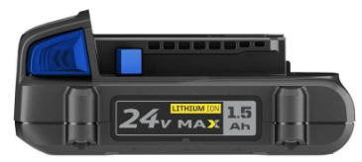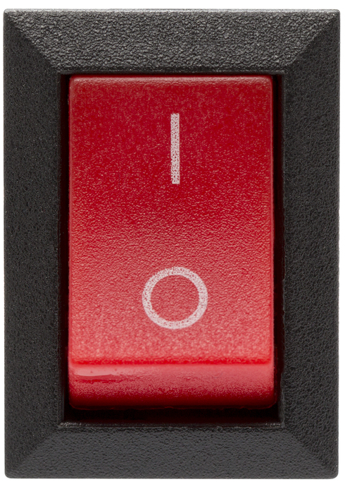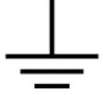

P19

P20

A1

A2

A3

A4

B1

B2

**3.3V**

**24V**

B3

B4



**3.3V**

P21

P22

P20

P21

P22

P19

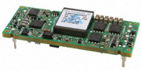

P0

P11

CPU B

CPU A

Power Switch

Level Shifters

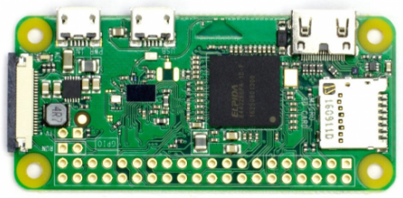

**5V**

**5V**

Pi Zero Wifi (Access Point)

P0

Level Shifters

DC/DC Converter

Battery

P11

P10

P10



Connector

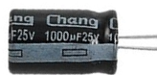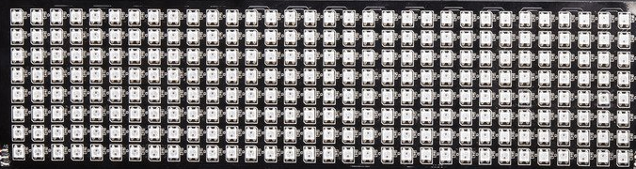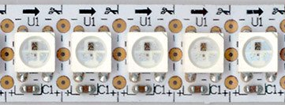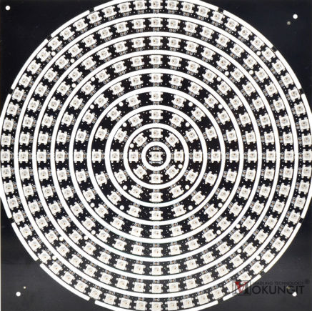

**5V**

A1

A3

A2

A4

B1

B2

B3

B4

241 pixels in the center of the top.

Four grids around the body. Each grid is 32*8 = 256 pixels.

54 pixels in short strips filling out the long axis of the top.

64 strips of 8 pixels wrapped around the brim. Divided into 2 sets of 256 pixels.

54 + 241 + 256*4 + 256*2 = 1831 total pixels



**NeoPixelStrip**

**NeoPixelStrip**

**NeoPixelStrip**

**NeoPixelStrip**

**SDCard**

**Parallax Serial Terminal**

Pixels

Pixels

Pixels

Pixels

Pi Zero (Web)

**Main**

Movie Info

(1 sector, 512 bytes)

Color Palette

Adjusted Colors

Two 1K Frame Buffers

**Parallax Serial Terminal**

Debug

Disk Info



pacman.txt

team.txt



Notepad



pacman.py



binMaker.py

10110010111

10110010111



CPUA

CPUB



**5858**

**5858**

a.bin

b.bin